Biology Summer Research Program
2004

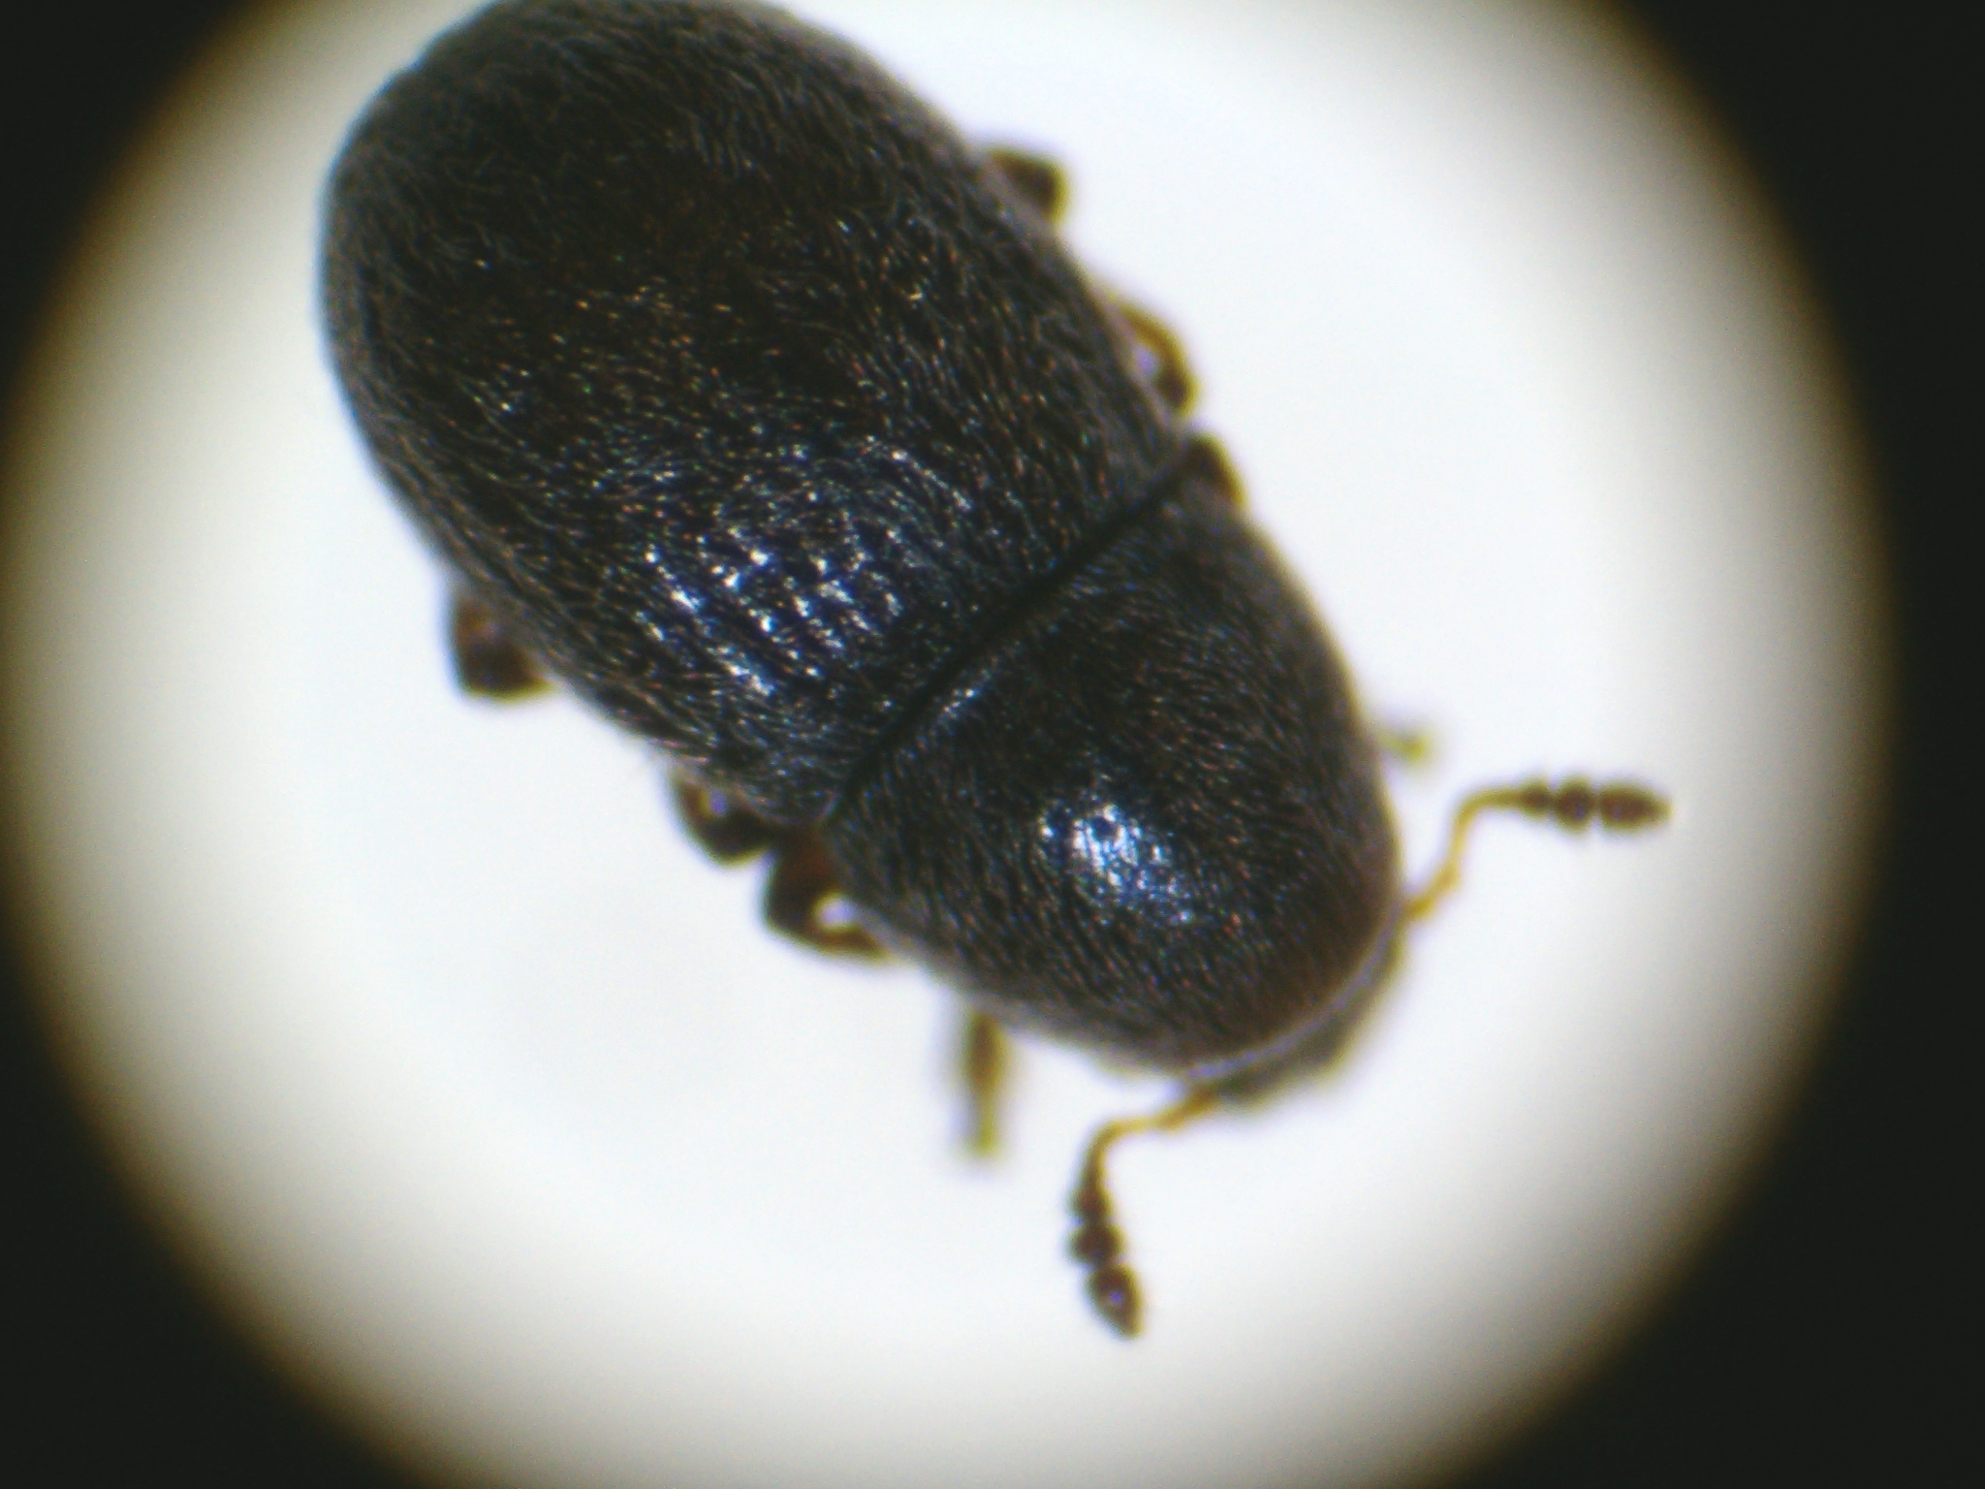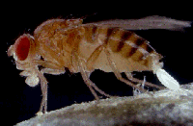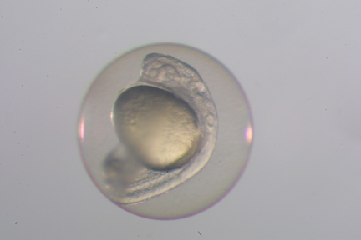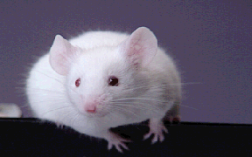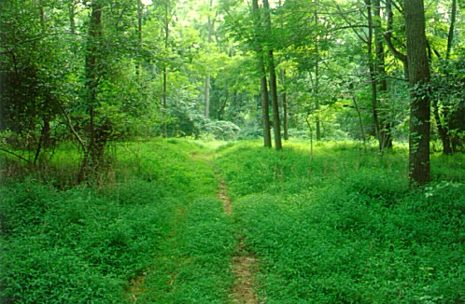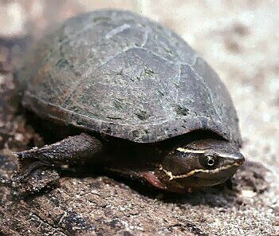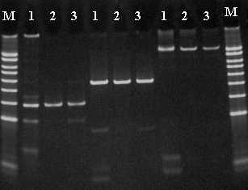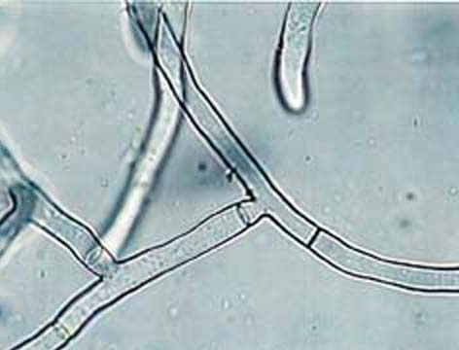
BSRP
The College of New Jersey

Overview

The Spring 2004 semester was nearly over when faculty in the Department of Biology learned of the possibility of seed money from the Office of the Provost to fund a summer research program for our majors. We quickly organized a meeting and determined that faculty interest was high, so we developed a short proposal (Appendix A) and submitted it to Provost Briggs. He agreed to the outline of the proposal and within a week we had a plan in place for the Biology Summer Research Program (BSRP) - an eight week research experience for students working closely with faculty members in Biology, with the option of free on-campus housing. Our stated goal was to develop research teams in each lab that included a faculty mentor, some experienced students (juniors and seniors), and some newer students (sophomores). Because of the condensed time frame for organizing the BSRP, we found that we needed to be flexible on the composition of teams within each lab, but across the entire program we were successful in offering the experience to a mixed group of rising sophomores, juniors, and seniors. Stipends for 19 students and housing in Townhouses South for 12 were funded by the program, along with stipends for four core faculty members, lab supplies, weekly breakfast meetings of the entire program, and even a canoe trip. The bulk of the funding was provided by the Office of the Provost, with the remainder from the Office of the Dean of the School of Science.

Seven faculty members participated. The four core faculty members were Jeff Erickson, Janet Morrison, Amanda Norvell, and Charlie Peterson. Jim Bricker, Marcia O’Connell, and Dennis Shevlin also sponsored research students in the program (Don Lovett had two students working with him as well, but they were at Woods Hole Biological Laboratory and funded though his NSF grant; Dennis Shevlin had one additional student at TCNJ also funded through a Sea Grant). We invited Chemistry summer students to our weekly meetings and social events, so we interacted with a few students from the Chemistry labs of Don Hirsh and John Allison as well.

Most of us had certain students in mind for the program, but we also had a number of slots to fill. So, we announced the opportunity via an email message sent to all Biology majors, who by this time had left campus for the summer. Within 24 hours we got nearly 50 responses ! Clearly, TCNJ Biology majors have intense interest in doing science with TCNJ professors.

Staff support for the program was provided by Ellie Fogarty in Academic Affairs, and Biology staff: Rich Cook, Luz Morales, and Shirley Whitney.

The Program

Each research team followed its own daily schedule, but generally students were active in the labs or in the field during regular work hours, from June 7-July 30 (more hours and at other odd times when the science demanded it). Students typically worked closely with their mentor on a daily basis. This close contact was one of the features of the program that students praised highly in their exit questionnaires (Appendix B).

We met each Wednesday morning for a breakfast meeting, usually structured around a planned discussion topic. These included the initial introductions to each other, descriptions of the labs’ projects, presentations of newly learned techniques in each lab, break-out groups for focused discussion of the projects among labs with shared interests, and reporting of initial findings. Nearly all students highlighted the weekly meetings as an important and valuable component of the BSRP, for they allowed the participants to create a scientific and social community of scholars. Students particularly enjoyed hearing about the research in other labs. Because of the weekly meetings, students became interested in each other’s work and were often found dropping in on other labs to see what was happening.

We included three social occasions that the students also noted quite favorably in their comments. During one Wednesday we went on a day-long canoe trip on the Delaware River, and we held two potluck dinners at the homes of faculty members. These activities also helped create a sense of community among our summer researchers that can not be valued highly enough.

The sense of the faculty was that the 2004 summer in our department felt much more like a graduate school than an undergraduate college. In fact, the experience was comparable to a lab rotation in grad school, where students join a lab for a couple of months to engage a new set of questions and learn new techniques. Faculty and students were present and working every day doing serious research, and talking to each other about science. The students who participated got a chance to experience the day to day work of a biologist

In the Labs

In this section each mentor has described the research in her/his lab.

Jim Bricker – Molecular Biology
Students: Kevin Gershuny (Senior), Reid Collins (Senior), Patrick Discepola (Junior)
DNA isolation and genetic characterization of corn snake and white-tailed deer specimens
Kevin and Reid investigated the genetic health status of the corn snake (Elaphe gutatta), an endangered species in NJ, using DNA isolation and PCR characterization (microsatellites). Patrick investigated the genetics of the white tailed deer (O. virginicus) in NJ, also using DNA isolation and PCR.
Reid and Kevin are continuing research in the lab during the Fall 2004 semester.

Jeff Erickson – Neurobiology
Students: Jason Salamandra (Senior), Nimit Saraiya (Senior)
Serotonin and the development of breathing behavior: ventilatory testing in serotonin-deficient Pet-1 knockout mice
The major goal of the project was to compare the breathing pattern of genetically altered mice (mutants that lack a transcription factor needed for the production of a full complement of brain serotonin neurons) with normal wild-type littermates during resting ventilation and in response to changes in environmental oxygen and carbon dioxide levels. The rationale for the research comes from previous studies demonstrating that brain serotonin levels can influence the development of respiratory control in mammals and a recently proposed hypothesis that at least some cases of human Sudden Infant Death Syndrome (SIDS) result from an underlying dysfunction of the brain serotonin system in conjunction with an environmental "trigger" factor, most likely a decrease in environmental oxygen or an increase in environmental carbon dioxide levels.
During the 8-week summer program Jason and Nimit gained considerable technical experience in the lab. Specifically, they learned the theory and operation of whole-body plethysmography and used the technique effectively to amass a considerable amount of high quality data on resting ventilation in four day-old mice and tested the ventilatory responses of these newborns to low environmental oxygen and high carbon dioxide levels. Both learned how to cut brain tissue using a cryostat, mount the frozen tissue sections onto glass microscope slides, perform immunohistochemistry to detect the presence of serotonin and one of its biosynthetic enzymes tryptophan hydroxylase in the brain tissue, and view the stained tissue sections using a research grade fluorescent microscope. In addition, they both learned important techniques in animal husbandry while helping with maintenance of the mouse colony.
Based on this initial experience, both Jason and Nimit elected to pursue a full year of research in my lab, utilizing the techniques they learned over the summer.

Janet Morrison – Plant Ecology
Students: Kerry Mauck (Senior), Kelly-Marie McCartney (Senior), Brian Dunn (Senior), Rob Kral (Junior), Sean Halloran (Senior)
Natural enemies and competition in native and invasive non-native forest plant interactions and
Tri-trophic interactions: a mycophagous beetle’s role in the plant-pathogen interaction between the grass Andropogon virginicus and the smut fungus Sporisorium ellisi
Our lab focuses on biotic interactions that may influence plant community structure and/or the population dynamics and evolution of natural plant populations. During the 2004 growing season, we ran a very large field experiment to investigate how four different forest plant species (including some non-native invasives) compete with each other, and if their interactions are mediated by the presence of natural enemies. Our method involves experimentally excluding different suites of enemies in our forests plots, including deer, insects, and fungi, and growing the plant species with and without competition in 256 plots, with the design replicated in three local forest preserves. Kerry, Kelly-Marie, and Brian have been working on the project since the Spring 2004 semester, and Rob joined us just for the BSRP, primarily to map the vegetation in each forest. Sean’s interest in insects inspired a new angle on a second project that my lab has been working on in the past few years - the interaction between an important local grass species, Andropogon virginicus, and a smut fungus pathogen that infects its flowers. During past work my students and I had noticed a tiny insect larvae inside many of the infected flowers. Sean decided to investigate the species identity of this beetle larva, determine its frequency in infected plants, if it eats the fungal spores, and if it is important in dispersing to or infecting new plant hosts.
The BSRP provided an opportunity for the students to gain experience in the design, installation and data collection phases of field experiments. They learned to design and build exclusion cages, set up transects and plots, grow test plants from seed in the greenhouse and then transplant to field plots, perform in situ photosynthesis measurements with the Li-Cor 6400 portable IRGA, assemble, use, and download data from portable microclimate data loggers, identify and map tree species, measure ground cover, enter and manage large datasets in Excel, and keep a field notebook. Perhaps most important, they learned how to work together as a research team. They were extraordinarily cooperative in taking care of the many tasks that these projects required.
Everyone except Rob is continuing research in our lab during the Fall 2004 semester, and Rob is interested in joining again in the future. I presented some of Sean’s BSRP results at a national meeting of the Ecological Society of America in August.

Amanda Norvell – Developmental Cell Biology
Students: Michael Coppola (Sophomore), Paul Discepola (Sophomore),
Kerri Matthes (Junior)
Molecular identification and characterization of a weak hypomorphic allele of squid.
My laboratory is interested in understanding how the Drosophila melanogaster egg is properly made, and more specifically how maternally derived factors control the correct development and patterning of the oocyte and the egg. The three students in the lab this past summer, Mike, Paul and Kerry, performed a detailed analysis of a mutant form of a gene called squid (sqd), sqdK12. The objective of their project was to sequence the mutant version of the sqd gene from K12 flies and compare that sequence to that of wild type, or normal flies, in order to identify the exact nucleotide change in the mutants. This information will allow us to begin to pinpoint the important regions of the Sqd protein responsible for its specific functions. These students were responsible for obtaining the DNA samples for analysis, amplifying the sqd coding regions by PCR and aligning and analyzing the DNA sequence once it was obtained.
Because this was the first laboratory experience for these students, they learned how to conduct an experiment from start to finish. They learned how to read and execute experimental protocols, how to maintain a laboratory notebook, how to trouble-shoot experimental problems and how to collect, analyze and interpret original data. More specifically, these students learned to isolate genomic DNA from flies, to design and order PCR primers, to perform PCR reactions, to resolve DNA by gel electrophoresis, and to isolate the DNA and prepare it for DNA sequencing. Importantly, these students were also responsible for a sophisticated computer-based analysis of the DNA sequence that they obtained.
Because of their lower class standing, these students are not currently directly involved in research on campus. All three, however, are interested in continuing with research in the future, either at TCNJ or through internship programs at other institutions. Each of them volunteered to come back into the lab during the fall semester to assist in the completion of this project.

Marcia O’Connell – Developmental Genetics
Students: Kaycie Hopkins (Sophomore), Kelly Pfeiffer (Sophomore)
Preparation and analysis of two genes involved in translational control during zebrafish embryogenesis.
The research in which Kaycie and Kelly participated is aimed at understanding how the synthesis of proteins during embryogenesis in zebrafish is regulated. In particular we were studying two genes, one that produces a protein whose levels increase dramatically after fertilization, and a second that produces a protein that regulates this increase. In order to pursue these studies Kaycie and Kelly prepared DNA constructs that contained either normal or mutant versions of these two genes. They analyzed the DNA constructs and used them to prepare their RNA products in vitro. These RNA products will be microinjected into zebrafish embryos so as to assess their effect on protein synthesis.
The students gained their first experience working in a molecular biology lab on new research. They learned numerous techniques in molecular biology such as gel electrophoresis, DNA transformation, restriction enzyme digestion, and in vitro transcription, and learned how to manipulate embryos of different stages.
Since both students are currently sophomores neither has room in their schedule to pursue research at this time. However, I have discussed future possibilities with both of them and they have both expressed interest in pursuing research in the future

Chuck Peterson – Animal Physiology
Students: Michael Pesa (Junior), Christina Albizati (Senior), Daisy Gomez (Senior)
Integrating the physiology and ecology of animals
Three students collaborated on several investigations that integrated the physiology and ecology of animals. We 1) measured metabolic rates of 17-year cicadas; 2) measured effects of feeding on metabolic rates of Anolis lizards; 3) compared mechanisms for regulating buoyancy in two local turtle species; 4) ran an intensive turtle-trapping program in Lake Sylva (on the TCNJ campus), in which we captured almost 300 individual turtles of five species, marked each with a unique number for later recognition, and released them for later recapture and determination of growth rates and survivorship; adult females were also monitored for reproductive activity via ultrasonography; and 5) attached radiotransmitters to adult female turtles and tracked their movements in an attempt to locate nesting and hibernation sites, and 6) obtained eggs from female turtles of two species, incubated them at two different temperatures in the laboratory, and measured their metabolic rates weekly to determine the energetic cost of development. We also took field trips to other New Jersey turtle habitats and the Tewksbury Institute of Herpetology, a center for breeding endangered turtle species.
Mike Pesa is continuing the egg study, now of hatchlings, as an Independent Research project this academic year.

Dennis Shevlin – Mycology and Phycology
Students: Peter Pak (Junior), Christopher Matulewicz (Senior; funded by Sea Grant)
Life cycle of the parasitic smut fungus Sporisorium ellisii and
Antioxidant production by microalgae
The general questions to be answered by Peter last summer were about the nature of the life cycle of the plant parasitic smut fungus Sporisorium ellisii, with some effort made to facilitate a better understanding of the classification of this poorly studied, yet ubiquitous fungus. Peter learned and used aseptic lab techniques to germinate and grow the teliospores made in abundance by this organism. He learned fluorescence microscopy to attempt to infer the location of meiosis in the life cycle and to determine if teliospore germination resulted in further spore production. Finally, he learned basic DNA techniques by extracting and assessing DNA from mycelia grown from teliospores in culture.
Chris worked on the optimization of antioxidant production by selected microalgae. He is mastering the techniques of axenic marine algal culture, determination of log growth phase, hydrophilic antioxidant extraction and sundry other matter pertinent to light measurement, etc. He is continuing his work in the Fall 2004 semester.

